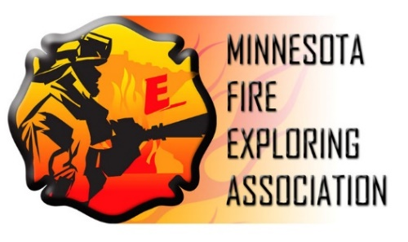
2019
Exploring
Scholarships

General Safety Fire Apparatus Scholarship $1,500
MN-FEA Scholarship(s) $ 500

BACKGROUND
The MN Fire Exploring Association is proud to offer a yearly scholarship program, made possible by generous contributions from corporations and local partners. The scholarships objective is to assist youth in our local Fire Exploring posts in pursuing careers within Public Safety or related fields and continuing the values of Exploring.

TIMELINE
February 22nd – Application Period Closes
March 15th – Recipients Notified
April 10th– Exploring Award Banquet
September 2019 or January 2020 – Upon successful completion of first semester, Award funding bank-transferred to institution where recipient enrolled.

MINIMUM REQUIREMENTS
- Must be an outgoing high-school senior or post-secondary student
- Registered as an active member of an Explorer Post in a Scouting Council within Minnesota or active with the MN Fire Exploring Association.

DESIRABLE REQUIREMENTS
- High school GPA of 2.5 or higher on a 4.0 scale
- At least two(2) years of Exploring experience

HOW TO APPLY
Interested Explorers must complete and return the attached application to the MN Fire Exploring Association offices (via address or email below) no later than Friday, February 23rd . Along with the attached application, please submit two (2) letters of recommendation from Exploring or other activity leaders. A portrait photo will also be required for successful applicants.
MN-FEA
Attn: Scholarships
1710 County Highway 10
Spring Lake Park, MN 55432
mnfeaboard@gmail.com

APPLICANT INFORMATION
Name___________________________________ Date of Birth_______________ Age________
Address_______________________________________________________________________
City_________________________________________________ State______ Zip___________
Telephone_________________________ E-Mail______________________________________
Father’s name (Guardian)__________________________________ Phone_________________
Mother’s name (Guardian)_________________________________ Phone__________________
Parent Signature (if under 18 years of age)___________________________________________

POST ADVISOR INFORMATION
Date____________ Post #___________ Organization__________________________________
Post Advisor Name______________________________________________________________
Post Advisor Signature___________________________________________________________
Address_______________________________________________________________________
City_________________________________________________ State_______ Zip__________
Work Telephone____________________________ Cell Phone___________________________
E-Mail________________________________________________________________________

EXPLORING EXPERIENCE
Describe your experience with Fire Services Exploring or other Posts that you have been involved with. This should include, at a minimum, the amount of time you have been involved, leadership positions, community service hours, and awards or accomplishments you have received.

CITIZENSHIP EXPERIENCE
List and describe experience you have with other organizations, groups, or clubs outside of Exploring. Please indicate the years you were involved, leadership positions, accomplishments and other relevant information.

OPTIONAL ADDITIONAL INFORMATION
Provide any additional information that you feel important such as work experience, personal hardships, what you have learned from volunteer experiences, unusual financial circumstances, etc.

FUTURE AMBITIONS
Submit a 500 word essay describing your plan and ambitions for post-secondary education and a career in that desired field. This should include, at a minimum, the institution(s) you hope to attend, the degree you will be seeking, any work or internship experience, and a future goal of job placement and career choice.

Attached two (2) letters of recommendation and a portrait photo of applicant to this application.

