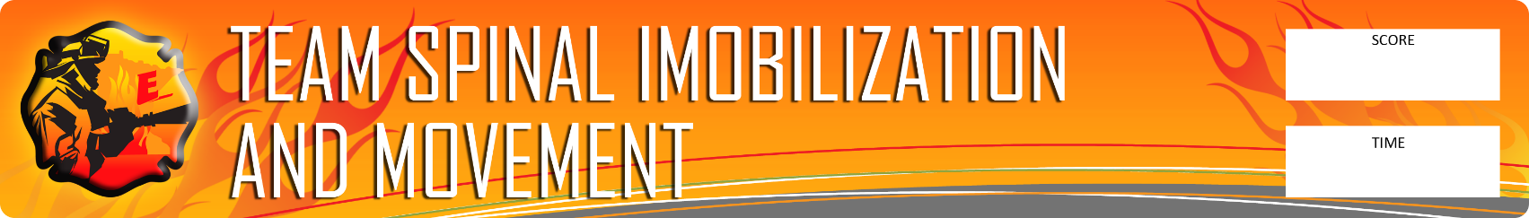

POST NAME
Scenario: Given a seated patient in an automobile, perform an initial patient evaluation, determine that the patient has possible neck and back injuries, immobilize the neck and body, and remove the patient from the vehicle using a long backboard.

Rules:
- Four Explorers from each post will participate. The skill sheet criteria must be followed. No running allowed.

Action: Assess, immobilize, and remove patient according to the attached criteria.

Equipment: Stop Watch, patient, long backboard, various cervical collars, head block and straps, vehicle

EVALUATE EACH TEAM ON: |  | Possible  Points | Actual  Points
1 | Scene safety | 1
2 | Takes or verbalizes body substance isolation precautions | 1
3 | Assess patient condition (victim is responsive – complaining of neck and back pain) | 1
4 | Timely direction of a member to manually maintain head in neutral in-line position | 1
5 | Assesses motor, sensory and distal circulation in extremities | 1
6 | Applies appropriate size cervical collar | 1
7 | Reassesses motor, sensory and distal circulation in extremities | 1
8 | Positions the immobilization device appropriately | 1
9 | Directs movement of patient onto device without compromising integrity of the spine | 1
10 | Immobilizes the patients torso to the device (done in order) | 1
11 | Secures the patients legs to the device (done in order) | 1
12 | Immobilizes patient’s head to the device (done in order) | 1
13 | Upon completion of immobilization, head is in the neutral position | 1
14 | Reassesses motor, sensory and distal circulation in extremities | 1
15 | Secures the patients arms | 1
16 | Applies padding to voids between the torso and board as necessary | 1
CRITICAL CRITERIA – 2 Points Each
1 | Did not release manual immobilization before it was maintained mechanically | 2
2 | Assessed motor, sensory and distal circulation prior to C-collar being applied | 2
3 | Patient was not manipulated or moved excessively during entire evolution | 2
4 | Head immobilization does not allow for excessive movement | 2
5 | Torso fixation does not inhibit chest rise, preventing respiratory compromise | 2
6 | Did not immobilize head before securing torso | 2
7 | Completed evolution within 10 minute time limit | 2
 | TOTAL SCORE | 30

Evaluator 1) _______________________________________________________________________________

Evaluator 2) _______________________________________________________________________________

Evaluator Notes: __________________________________________________________________________________________________________________________________________________________________________________________________________________________________________________________________________________________________________________________________________________________________________________________________________________________________________________________________________________________________________________________________________________________________________________________________________________________________________________________________________________________________________________________________________________________________________________________________

