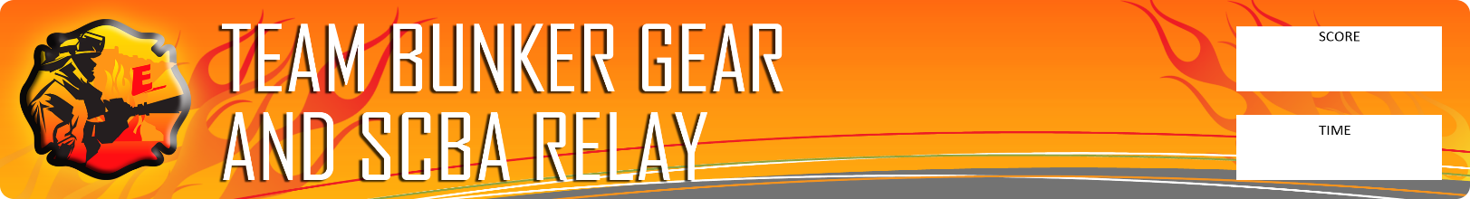
N/A

POST NAME
Scenario: This timed event will simulate the need to rapidly don ones’ personal protective equipment in order to rapidly enter a hazardous environment. Four Explorers will complete this event in sequence of one-another for an overall team time.

Rules:
- Explorers must start without any firefighting gear on and with footwear completely on.
- All gear must be properly donned (boots, pants, hood, jacket, SCBA, mask, helmet, and gloves).
- All gear must be separated (besides pants/boots) and straps fully extended. This includes SCBA mask from hose or regulator.
- SCBA must be turned on with air properly flowing through the mask.
- Time ends when last piece of equipment is on securely and properly
- 5 Seconds will be added for each infraction.
- The next Explorer may start when all necessary pieces of the ensemble are properly donned, air flowing through the mask, and the Explorer claps his/her hands. A violation for starting early will be 5 seconds.

Action: Properly don and operate equipment.

Equipment: Stop Watch, Judging Forms

EVALUATE EACH INDIVIDUAL ON: |  | Penalty  (Seconds) | 1 | 2 | 3 | 4
1 | SCBA cylinder not fully turned on | +5
2 | Buckles, flaps, or zippers on the coat not secured | +5
3 | Chin strap not in place or helmet not tight | +5
4 | SCBA mask straps not cinched down | +5
5 | Shoulder straps on the SCBA not fastened and tight | +5
6 | Waist strap not fastened | +5
7 | Gloves not on hands | +5
8 | Collar not up, earflaps not down, or hood not on properly | +5
9 | Next member started before the last explorer was finished properly donning. | +5
 | TIME | :
 | PENALTIES | :
 | TOTAL TIME

Evaluator 1) _______________________________________________________________________________

Evaluator 2) ______________________________________________________________________________

Evaluator Notes: __________________________________________________________________________________________________________________________________________________________________________________________________________________________________________________________________________________________________________________________________________________________________________________________________________________________________________________________________________________________________________________________________________________________________________________________________________________________________________________________________________________________________________________________________________________________________________________________________

